Using Terraform to manage infrastructure through Azure DevOps pipelines is a powerful way to automate your infrastructure as code (IaC) workflows. Here’s a step-by-step guide to set up a Terraform Azure DevOps pipeline:

**Prerequisites**

1. **Azure DevOps Account**: Ensure you have an Azure DevOps account and a project created.
2. **Service Principal**: Create a service principal in Azure to authenticate Terraform with Azure.
3. **Terraform Configuration**: Have your Terraform configuration files ready in a repository.

**Steps to Set Up the Pipeline**

**1. Create a Service Principal**

First, create a service principal that Terraform will use to authenticate with Azure.

az ad sp create-for-rbac --name terraform-sp --role Contributor --scopes /subscriptions/<subscription-id>

Note the appId, password, and tenant from the output, as these will be used in the Azure DevOps pipeline.

**2. Store Secrets in Azure DevOps**

1. Navigate to your Azure DevOps project.
2. Go to **Pipelines** > **Library** > **+ Variable group**.
3. Create a new variable group (e.g., TerraformSecrets) and add the following variables:
   * ARM_CLIENT_ID: Your service principal’s appId.
   * ARM_CLIENT_SECRET: Your service principal’s password.
   * ARM_SUBSCRIPTION_ID: Your Azure subscription ID.
   * ARM_TENANT_ID: Your Azure tenant ID.

Mark ARM_CLIENT_SECRET as a secret.

**3. Create an Azure DevOps Pipeline**

1. Go to **Pipelines** > **Create Pipeline**.
2. Select your repository containing the Terraform configuration.
3. Choose the YAML pipeline and start with an empty pipeline.

**4. Define the Pipeline YAML**

Below is an example of a complete YAML file for running Terraform in an Azure DevOps pipeline:

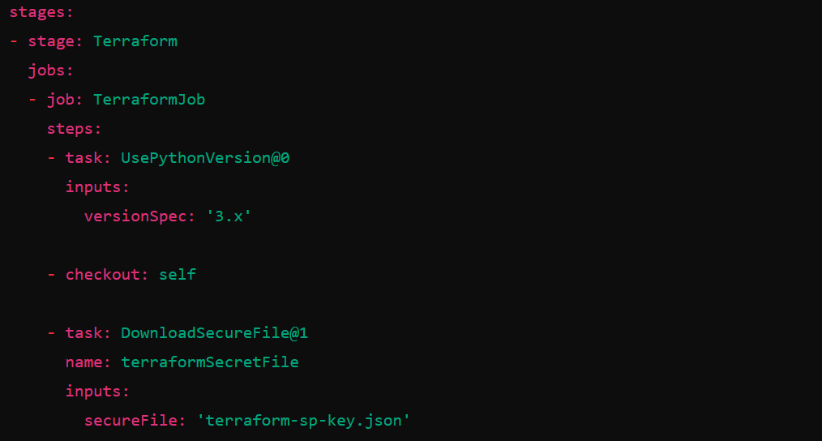

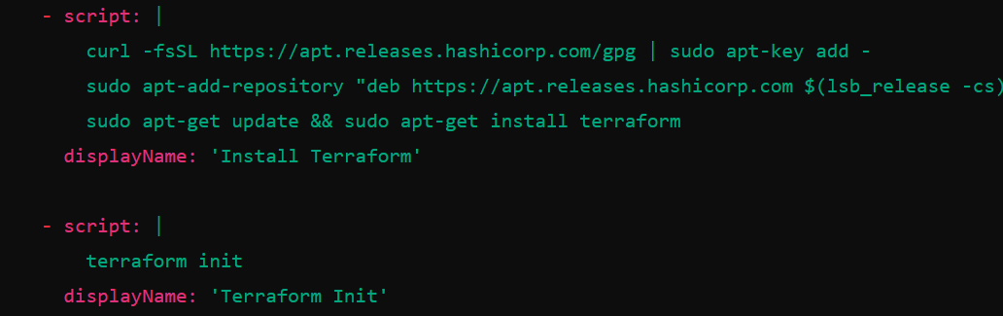

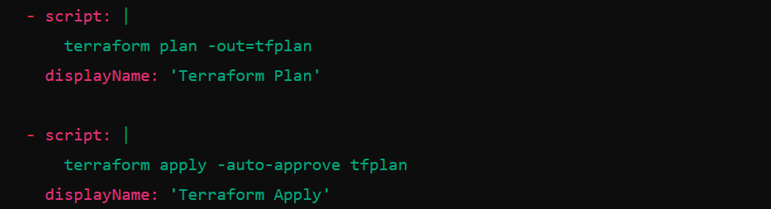

**5. Save and Run the Pipeline**

1. Save the pipeline YAML file.
2. Run the pipeline to ensure everything is set up correctly. The pipeline will perform the following actions:
   * Install Terraform.
   * Initialize Terraform.
   * Generate a Terraform plan.
   * Apply the Terraform plan.

**Additional Considerations**

* **Backend Configuration**: If using remote state storage, configure the backend in the terraform init command.
* **Terraform Version**: Specify the required Terraform version in your configuration to ensure compatibility.
* **Error Handling**: Implement error handling and notifications for failed pipeline runs.

By following these steps, you can effectively automate your Terraform workflows using Azure DevOps pipelines, ensuring consistent and repeatable infrastructure deployments.